**Project Design Phase**

|  |  |
| --- | --- |
| **Date** | 27-05-2025 |
| **Team ID** | LTVIP2025TMID31770 |
| **Project Name** | Sustainable Smart City Assistant Using Ibm Granite LLm |
| **Maximum Marks** | 2 Marks |

**Proposed Solution Template:**

**Project team shall fill the following information in the proposed solution template.**

|  |  |  |
| --- | --- | --- |
| **S.No** | **Parameter** | **Description** |
| **1** | **Problem Statement (Problem to be solved)** | **Urban areas lack an integrated digital assistant for sustainability tracking and citizen engagement.** |
| **2** | **Idea / Solution description** | **An AI-powered Smart City Assistant offering dashboards, eco-tips, forecasting, and feedback tools.** |
| **3** | **Novelty / Uniqueness** | **Combines modular AI tools for KPIs, citizen input, and sustainability insights in one platform.** |
| **4** | **Social Impact / Customer Satisfaction** | **Empowers citizens and officials to make informed decisions for greener, smarter urban living.** |
| **5** | **Business Model (Revenue Model)** | **Freemium model for municipalities, with premium analytics and dashboard features.** |
| **6** | **Scalability of the Solution** | **Easily extendable to other cities by updating datasets and local policies without code overhaul.** |

# Sustainable Smart City Assistant: Project Report

# 1. INTRODUCTION

## 1.1 Project Overview

## The Sustainable Smart City Assistant is a cloud-based AI-powered platform designed to enhance urban living by providing citizens and administrators with intelligent insights and services. Leveraging generative AI and open APIs, the assistant facilitates document summarization, feedback analysis, anomaly detection, and sustainability forecasting. The modular backend and user-friendly dashboards streamline service delivery, improve data-driven decisions, and encourage eco-conscious behavior.

## 1.2 Purpose

## The objective of this project is to assist smart cities in automating and improving interactions between citizens and the urban ecosystem. Through AI-backed services like KPI forecasting, eco tips, sustainability reporting, and feedback handling, the assistant empowers stakeholders with tools for informed decision-making, improved governance, and enhanced sustainability.

# 2. IDEATION PHASE

## 2.1 Problem Statement

Modern cities generate vast volumes of data but struggle to convert it into actionable, citizen-centric services. Administrative overload, lack of real-time insights, and inefficient feedback loops hinder smart city effectiveness. An AI-powered solution is needed to bridge this gap.

## 2.2 Empathy Map Canvas

* **Says:** “I want quick access to civic updates,” “Can someone simplify these lengthy reports?”
* **Thinks:** “Is my feedback reaching the authorities?” “Are we on track with sustainability goals?”
* **Does:** Browses government portals, submits feedback, reads public documents.
* **Feels:** Disconnected, uncertain, and overwhelmed by complex data and slow services.

## 2.3 Brainstorming

Key ideas discussed:

* AI summarization of documents and policies
* Feedback sentiment analyzer
* KPI forecasting for sustainability
* Real-time chat assistant
* Eco tips generator and anomaly detection
* Role-based dashboards for citizens and administrators
* Use of FAISS for vector similarity search
* Integration of OpenAI APIs for response generation

# 3. REQUIREMENT ANALYSIS

## 3.1 Customer Journey Map

A citizen logs in to the dashboard, submits feedback, accesses smart summaries of policy documents, views KPI forecasts, and receives sustainability tips. Admins monitor city performance, review feedback analytics, and generate reports automatically using AI.

## 3.2 Solution Requirement

- Functional requirements: Login system, document summarizer, feedback analysis, KPI forecast, chatbot, sustainability report generator.

- Non-functional: Scalability, performance, security, and easy cloud deployment.

## 3.3 Data Flow Diagram

* **User input** (login or quiz generation)
* **Request to backend API** (built with Node.js + Express)
* **Query to database** (MongoDB Atlas for storing and retrieving performance data)
* **LLM response** (from OpenAI GPT-4 or Cohere Command R+ via API)
* **Result rendered on frontend** (using Next.js for UI and routing)

**High-Level Data Flow**

[Citizen/Admin]

↓

[Login / Submit Request]

↓

[FastAPI Backend]

↓

+-------------------------------+

| 1. Validate User & Input |

| 2. Route to AI/Vector Module |

| 3. Retrieve / Predict Result |

+-------------------------------+

↓

[Streamlit Frontend Renders Response]

↓

[Displayed to User]

The user initiates a request from the UI. It is routed to the backend where user credentials are validated and necessary data is fetched or stored. Based on the request (login, quiz, performance), AI services are triggered and the result is sent back to the UI.

**System Diagram**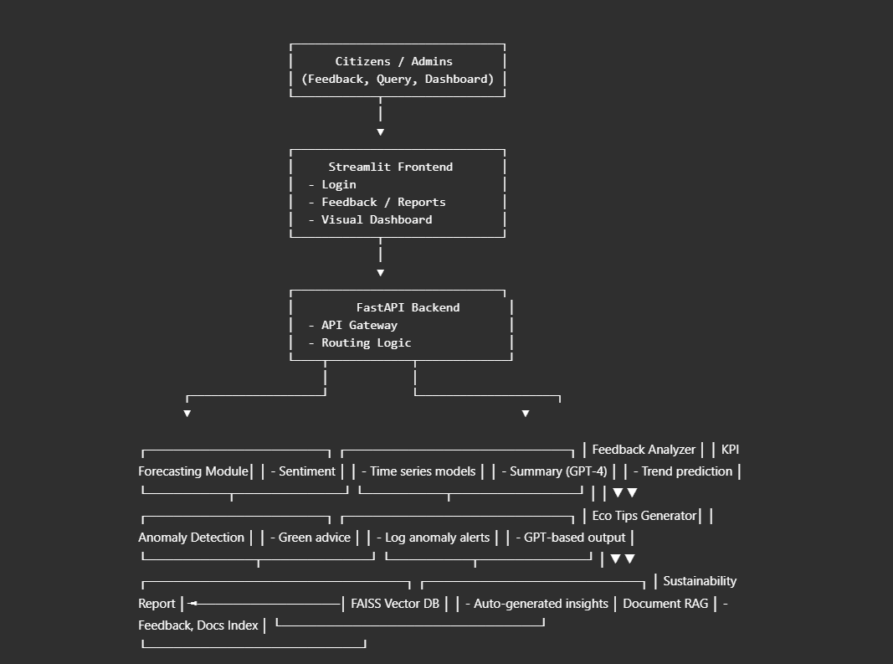

**Solution Architecture Diagram:**

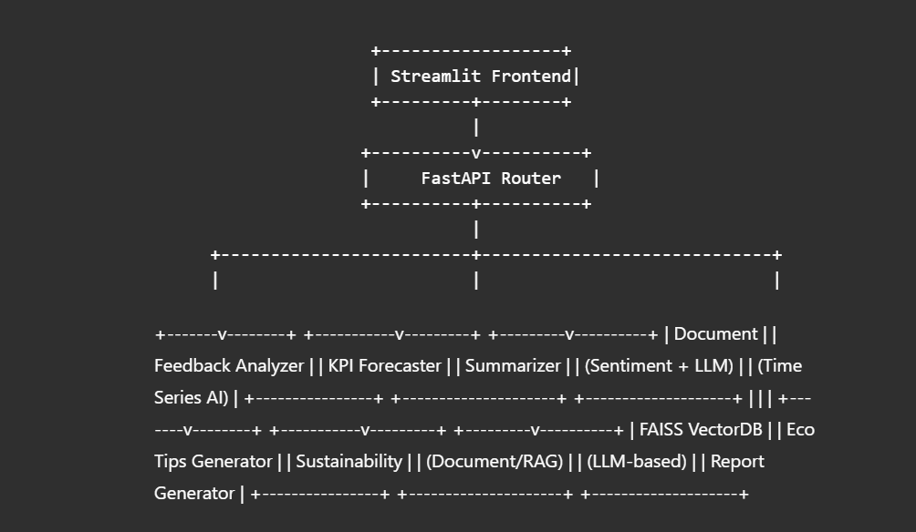

## 3.4 Technology Stack

* **Frontend:** React.js with role-based routing and dynamic component rendering
* **Backend:** FastAPI (Python) for handling services and AI interactions
* **AI Model Access:** OpenAI API key (GPT-based models used for generation and classification)
* **Database:** Pinecone (FAISS alternative) or local vector store for feedback and summary embeddings
* **Authentication:** Firebase Authentication with JWT handling
* **Cloud Deployment:** Render and VIE-based deployment for CI/CD and scalable hosting

# 4. PROJECT DESIGN

## 4.1 Problem-Solution Fit

## The assistant addresses common smart city challenges like slow feedback loops and complex documentation by automating key tasks using AI. Citizens get simplified, real-time insights while city administrators make faster, data-driven decisions.

## 4.2 Proposed Solution

## A smart assistant dashboard featuring:

## Automated document summarization

## AI-based feedback classification and sentiment detection

## KPI trend forecasting using time-series AI models

## Sustainability tips and anomaly alerts

## Real-time chat interface for queries

## Admin dashboard with analytics and report generator

## 4.3 Solution Architecture

* **Frontend**: React components with conditional rendering for citizen/admin roles
* **Backend**: FastAPI modules for summarization, feedback parsing, forecast modeling, and AI chat
* **Vector DB**: FAISS to store embeddings of feedback and queries for similarity-based lookup
* **OpenAI API**: Used to generate summaries, responses, and sustainability suggestions
* **Cloud Deployment**: Hosted on Render with custom domain and secure environment variables

# 5. PROJECT PLANNING & SCHEDULING

## 5.1 Project Planning

* **Week 1:** Ideation, requirement analysis, and OpenAI API setup
* **Week 2:** FastAPI backend implementation and integration with FAISS
* **Week 3:** Frontend UI design and Firebase login setup
* **Week 4:** Feature testing, performance tuning, and deployment via Render

# 6. FUNCTIONAL AND PERFORMANCE TESTING

## 6.1 Performance Testing

# Tests were run for:

# API latency under multiple users

# Summarization response time

# Forecasting accuracy (using synthetic KPI datasets)

# Secure routing and JWT-based access control

# Front-end responsiveness was validated on mobile and desktop browsers to ensure accessibility.

# 7. RESULTS

## 7.1 Output Screenshots

Screens include:

* User login and dashboard interface
* Feedback sentiment visualizations
* Real-time KPI forecasts
* Summarized reports from uploaded policy documents
* Admin analytics page with report generation
* Chat assistant UI for citizen queries

Each screenshot demonstrates how the system personalizes and simplifies city interactions.

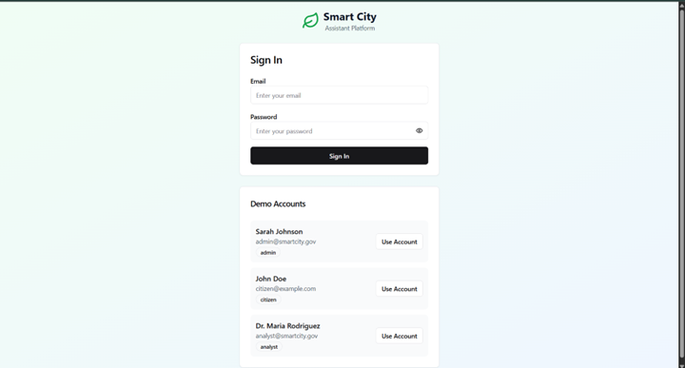

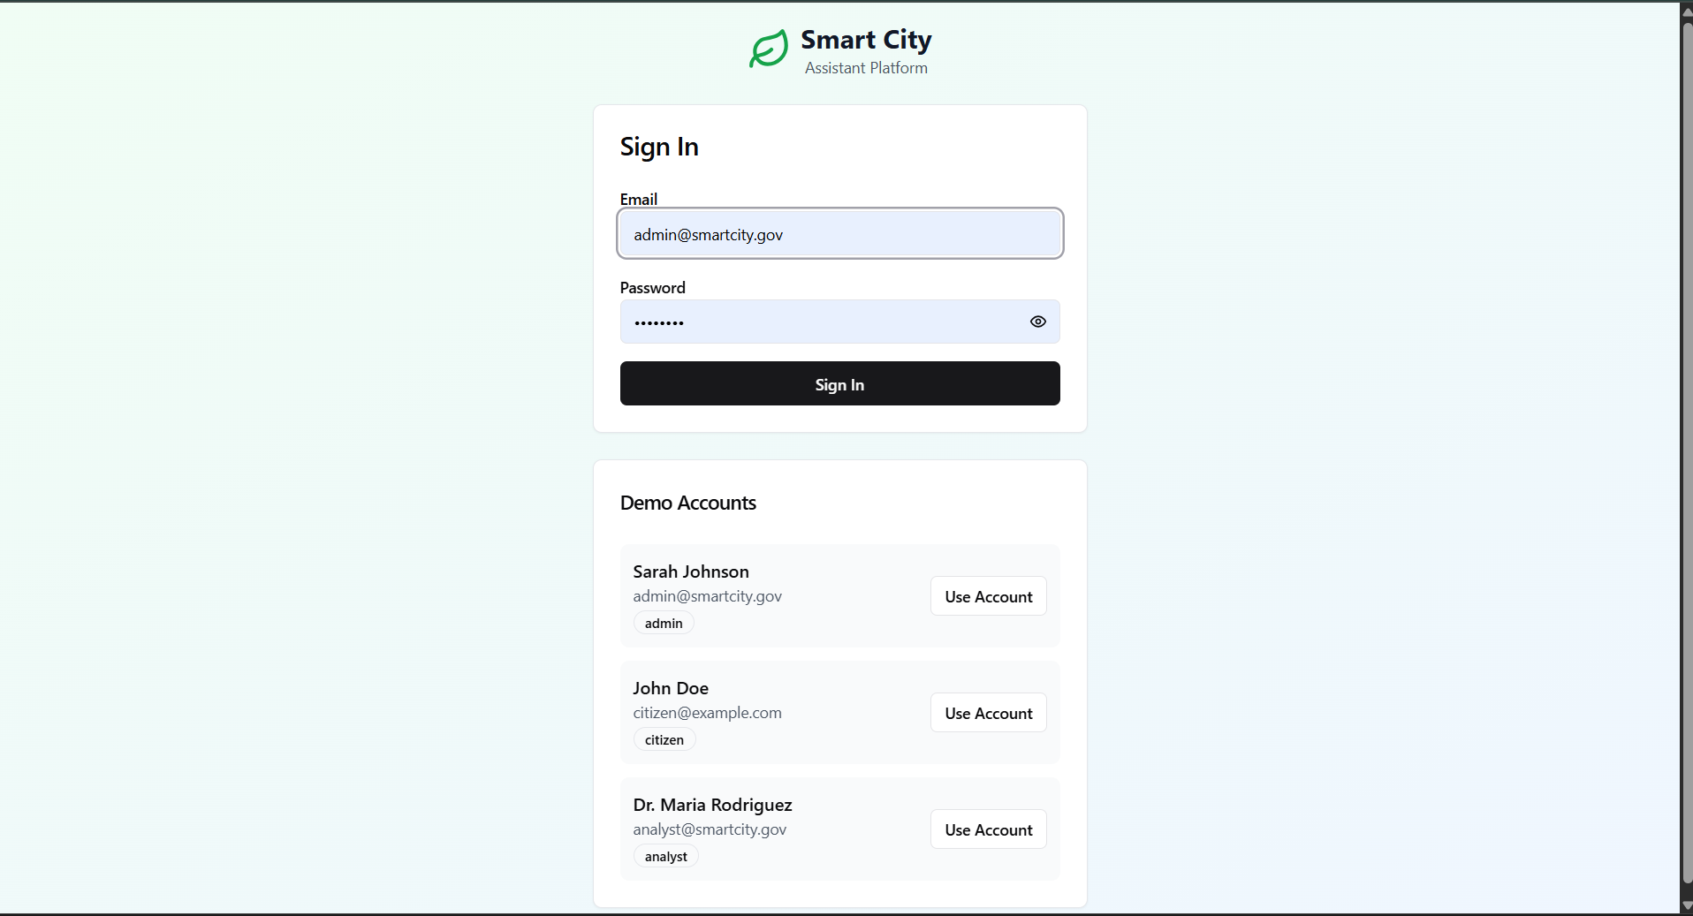

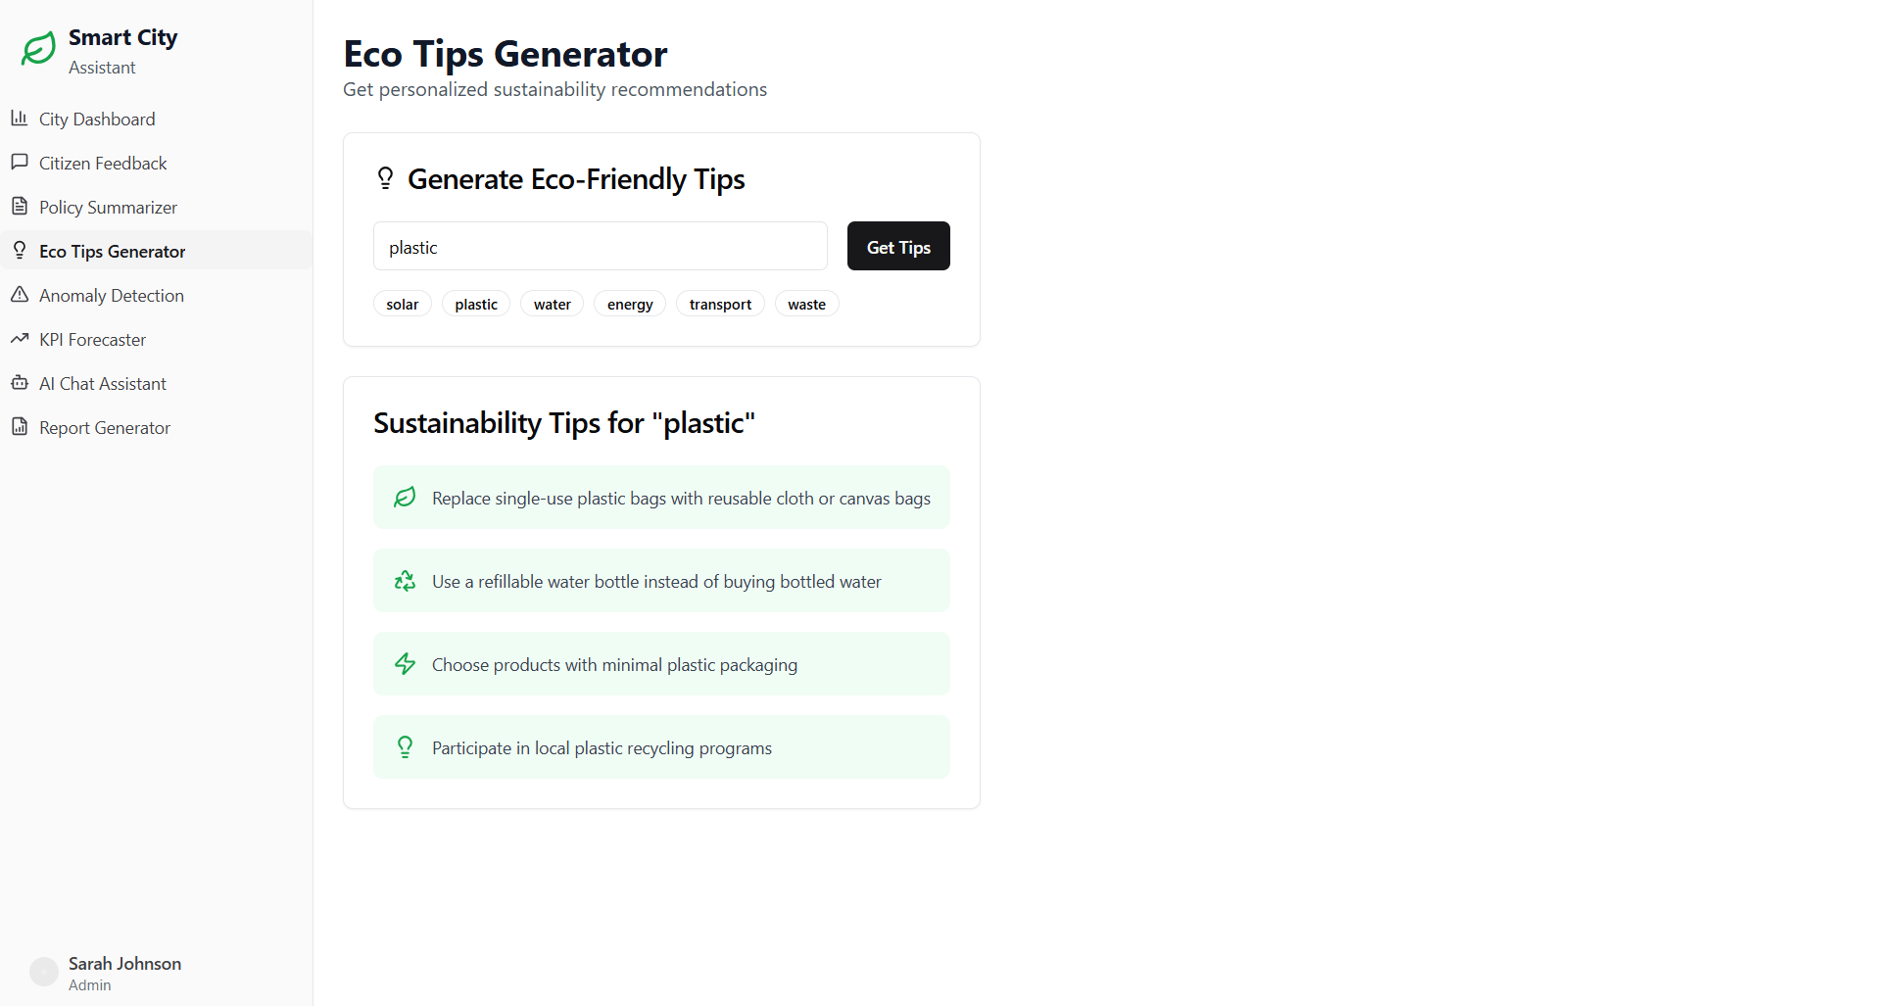

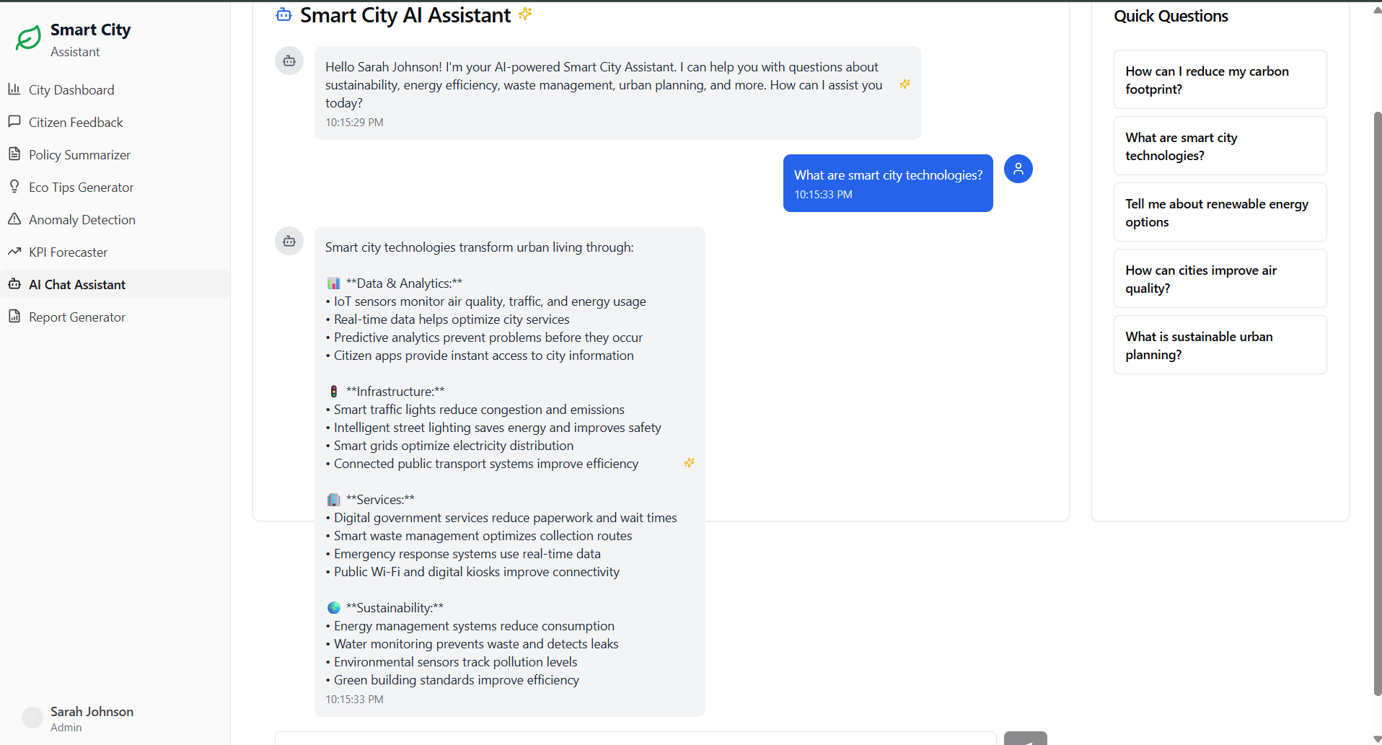

# 8. ADVANTAGES & DISADVANTAGES

# Advantages

# Real-time AI insights from feedback and documents

# Simplified citizen interaction with smart city services

# Role-based dashboards for better data segmentation

# Sustainable forecasting and eco-awareness generation

# Disadvantages

# Dependency on stable internet and OpenAI API availability

# Initial deployment setup may require technical know-how

# Data limitations without full-scale city integration

# 9. CONCLUSION

# The Sustainable Smart City Assistant bridges citizens with administrative systems using generative AI. It empowers better governance, enhances transparency, and promotes sustainability through intelligent automation. With its modular and scalable design, it can evolve into a full-featured smart city hub.

# 10. FUTURE SCOPE

# Expansion to support multilingual AI services

# Integration with IoT sensor data for real-time environmental updates

# Voice-based AI assistant for accessibility

# Scheduled report dispatch and alert system for anomalies

# Integration with public transport, water, and energy departments

# 11. Project Links & Demo

## GitHub & Project Demo Link

- GitHub: <https://github.com/mallikaponnada/smart-city-assistant>  
- Demo Video: <https://drive.google.com/file/d/1vQ05XsoCnsrZZpiGWjxhAuYdM9YNIahf/view?usp=sharing>  
